Tools and Tool Calling
01.07.2025

Tool
A tool is just a python function (or API) that is packaged in a way the LLM can understand and call when needed.
LLMs are great at Reasoning and Language generation. But they can’t do reliable maths , call APIs , run code i.e they can think and speak but they do not have hands or legs.
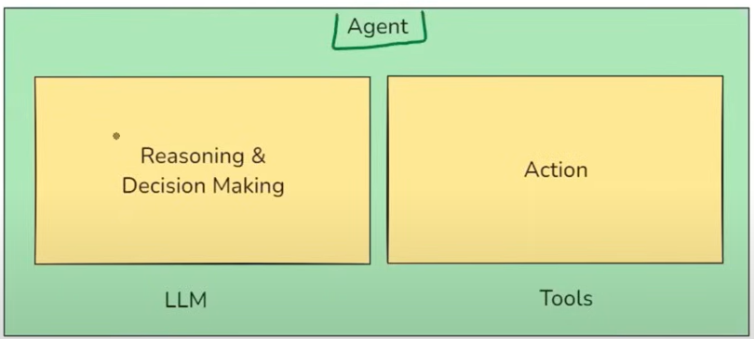
An AI agent is an LLM-powered system that can autonomously think , decide and take actions using external tools or APIs to achieve a goal.

Now we have two types of tools : Built-in tools and Custom tools.

Built-in tools :
A tool in langchain already provides for you - it’s prebuilt , production-ready , and requires minimal or no setup.
E.g. DuckDuckGoSearch , ShellTool etc.

Custom Tools :
A tool that you define yourself . Use them when you want to call your own API.

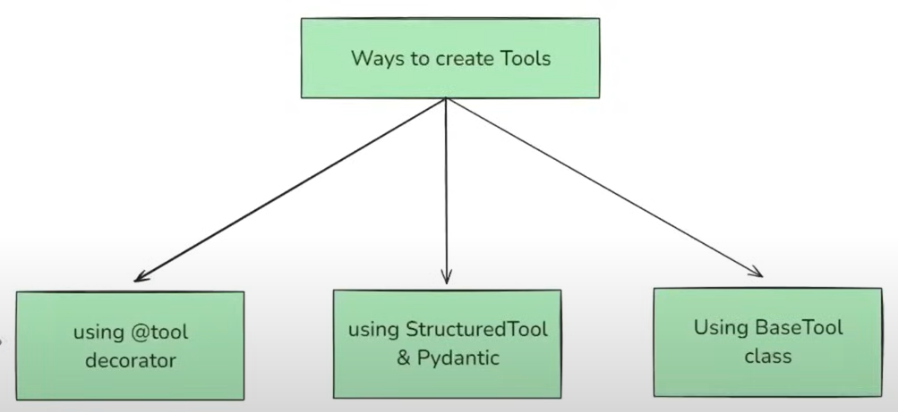
- @tool decorator - simple method
- Structured Tool - where the input to the tool follows a structured schema , typically defined using a Pydantic model.
- BaseTool - Defines the core structure . Structured tool ,@tool built on top of Base Tool.

A ToolKit is just a collection of related tools that serve a common purpose packed together for reusability. E.g GoogleDrive Toolkit .

Now understand the flow :
- We have a Tool , now we will bind it with a llm i.e. Tool binding

- Tool Binding - the step where you register tools with a LLM so that it knows what tools are available (name) , what each tool does (description) , what input format to use (schema). When it is done with it now LLM sends input to the tool in that format.
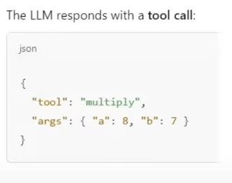
- Tool Calling - the process where LLM decides during a conversation or task that it needs a specific tool and generates structured output as (name of the tool , arguments to call with). The LLM does not actually run the tool - it just suggests the tool and the input arguments . The actual execution is handled by Langchain or you(user).

- Tool Execution - the step where the actual Tool is run either by langchain or user using the input arguments that the LLM suggested during tool calling.

